Safe Work Practice
TASK – Care and Use of Hearing Protection
This task may only be performed by trained and authorized personnel.

Hazards Present:  - Noise | Personal Protective Equipment  (PPE)  or Devices Required:  - CSA approved hearing protection | Additional Training  Requirements:  - Audiometric baseline testing within 70 days of exposure to noise over 85 dBA  - Annual audiometric testing  - Hearing and noise training

NOTE: All procedures obtained from mySafetyAssistant™, operator manuals or other samples must have the consultation of workers and be thoroughly reviewed to ensure they are accurate for your workplace and your jobs!

NOTE: Workers must be trained in a way that demonstrates they are competent. JUST READING a SWP is NOT training. Workers must demonstrate they can safely perform task and trainer/supervisor must follow up regularly to ensure workers are performing task in a safe manner. Document each occurrence in the employee’s training record.

Some signs that you should be wearing hearing protection include:

- If it is necessary for you to speak in a very loud voice, or shout directly into the ear of a person to be understood, it is likely that the noise level is high enough to require hearing protection.

- If you have roaring or ringing noises in your ears at the end of the workday, you are probably being exposed to too much noise.

- If speech or music sounds muffled to you after you leave work, but it sounds fairly clear in the morning when you return to work, you are being exposed to noise levels that are causing a temporary hearing loss. In time, this can become permanent if you do not take care.

Proper Fitting

- The amount of protection you attain depends on obtaining a good seal and even a small noise leak can substantially reduce the effectiveness of the protector.
- Remember to check the seal several times each day. Protectors - especially ear plugs - have a tendency to work loose as a result of talking or chewing, and must be resealed occasionally.
- Properly designed, fitted and clean ear protectors will cause no more discomfort to most workers than wearing a pair of safety glasses.
- Earplugs are made of soft material such a neoprene to prevent injury to the ear canal. Skin irritations, injured eardrums or other adverse reactions from using ear plugs are very rare if they are kept reasonably clean.
- There are many different styles, types and brands of ear protectors available, but when correctly fitted, they all provide similar levels of protection. The best hearing protector for you is one that fits correctly so that you can wear it properly.

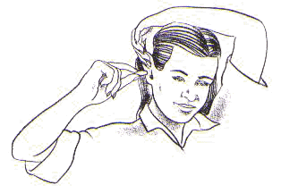
Inserting the ear plugs:
- Always wash your hands before handling the ear plugs to prevent ear infections
- Inspect ear plugs for cracks, tears, dirt and general wear and tear.
- To insert a supple foam plug, roll the plug between your fingers and thumb to make it thinner, making sure there are no wrinkles or folds in the plug.
- Take one hand behind your head and pull your ear outward and upward to widen the auditory canal. Insert the ear plug well into the canal and hold it in place while it expands.
- NOTE: Don't be afraid to place the plug into the ear canal. You cannot hurt your eardrum because the plugs are too short to reach it. If the seal is not tight and placed too shallow, the earplug will not be effective.

Ear Muffs
- Inspect ear muffs for cracks, tears, dirt, and general wear and tear
- Anything that comes between your ear and the ear muff will make them less effective thus reducing your level of protection! Hair, eyeglasses, and earrings are factors that must be considered when putting on your ear muffs.
- When choosing eyewear you may want to purchase glasses with thin temples so they don't interfere with the seal.
- Some ear muffs attach to hard hats to form a good seal when wearing a hard hat.
- Adjust the headband so the ear muffs are resting comfortably on your head. The cups should cover your entire ear.
Canal Caps
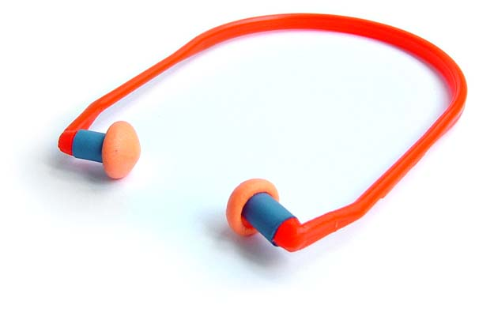
- Inspect canal caps for cracks, tears, dirt and general wear and tear.
- Canal caps have flexible tips that act as caps which plug the ear canal. They differ from plugs because they DO NOT extend into the ear canal, only close the ear opening. Therefore, they do not give you as much protection as ear plugs or ear muffs.
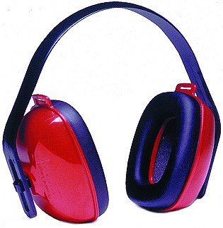
- Canal caps are NOT designed for long term wearing, but are ideal for situations where hearing protection must be taken on and off frequently. Insert canal caps much as you would ear plugs. Reach behind your head with one hand and pull the outer ear up and back, then insert the tips of the caps into the ear, firmly pushing and wiggling them into place.
- Remember the band wraps around the back of your head.

NOTICE: Report all hazardous situations to your supervisor without delay!

Guidance Documents / Standards /  Applicable Legislation / Other:  Guidance Documents:  - Manufacturer’s Instructions / Manual  CSA Standards  - CSA Z94.2-02, Hearing Protection Devices – Performance, Selection, Care and Use  - Safe Manitoba Guideline for Hearing Conservation and Noise Control  Manitoba Workplace Safety and Health Regulation, MR 217/2006 as amended:  - 2.1.1 Safe Work Procedures  - 6.1 Personal Protective Equipment  - 12 Hearing Conservation and Noise Control | This Safe Work Practice will be reviewed any time the task, equipment, or materials change and at a minimum every three years.  Completed / Approved By:  Date Completed:  SWP Last Reviewed / Revised by and date:
This Safe Work Practice has had the consultation of the following workers:

Name_____________________ Signature ____________________ Position _______________ Date: _________
Name_____________________ Signature ____________________ Position _______________ Date: _________
Name_____________________ Signature ____________________ Position _______________ Date: _________

